Assignment
Bioinformatics (Proteins and its domains)

Submitted to:
Dr Farrukh Jamil
Submitted by:
Usama Sarwar
FA17-BSCS-090
Date of Submission
July 8, 2020



COMSATS UNIVERSITY ISLAMABAD
SAHIWAL CAMPUS

Q1. Find one example of four domains of alpha helix.
- α helix domain
Alamethicin, a transmembrane voltage gated ion channel, acting as a peptide antibiotic.

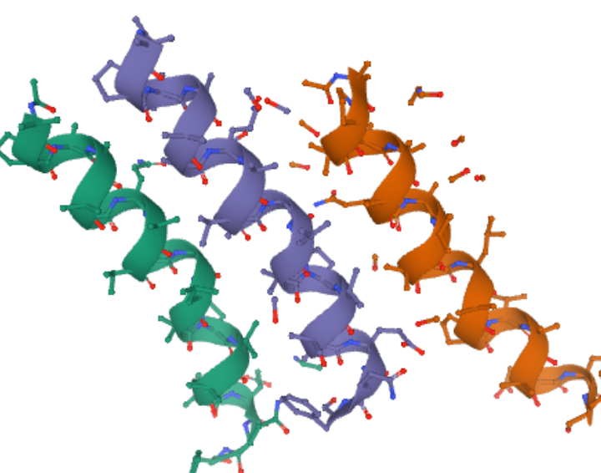

- αα alpha helix domain
ColE1 Rom protein, RNA binding protein, found in plasmids and involved in their replication.

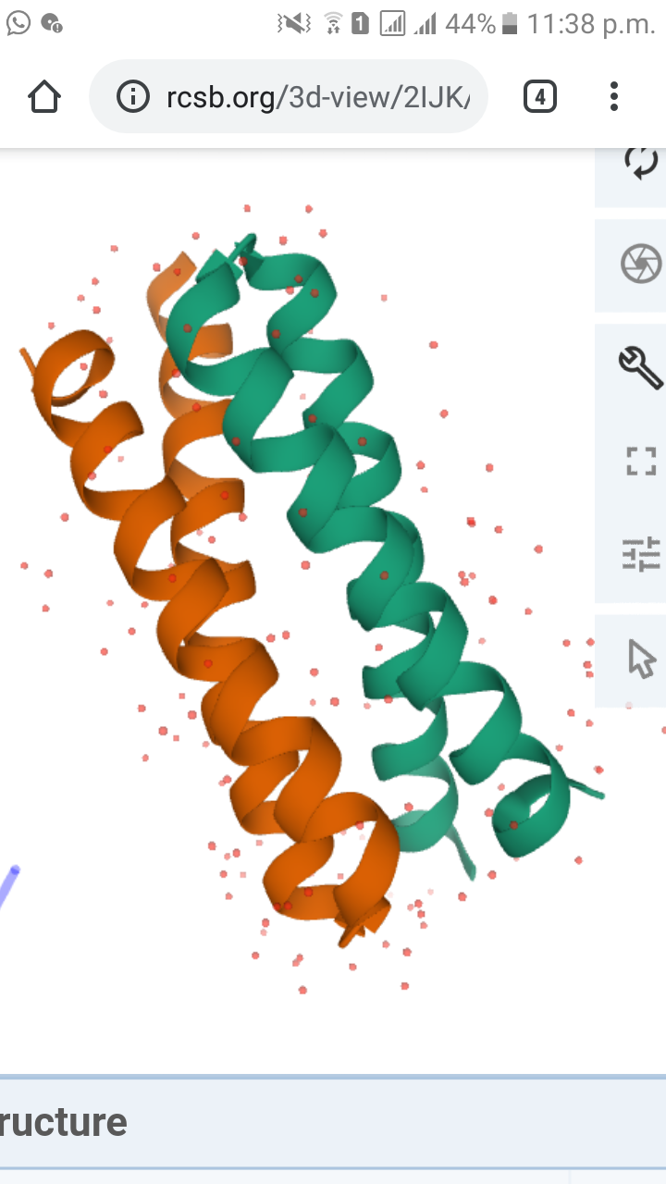

- αααα alpha helix domain
Interleukin-2, a cytokine, regulate the cells of the immune system.
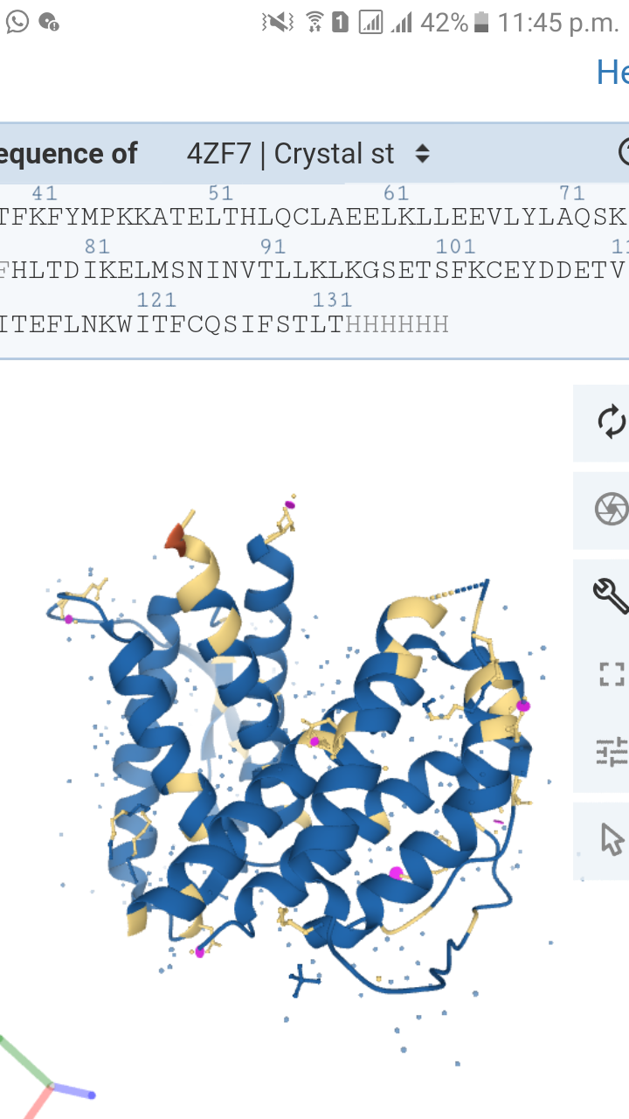

- 8α alpha helix domain
Myoglobin, a sperm whale MB, involved in stable pocket formation for the non-covalent binding of heme prosthetic group.
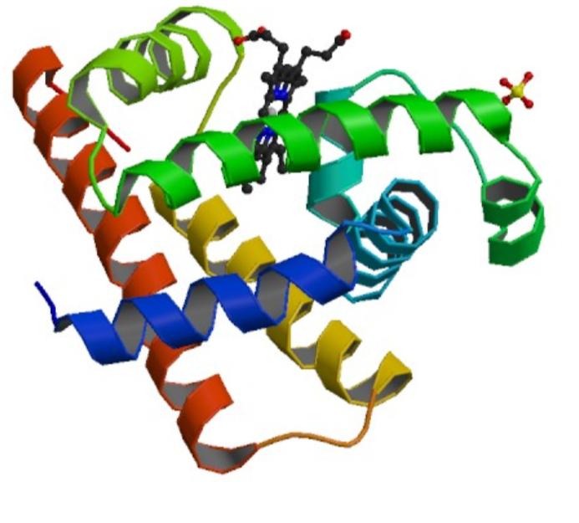

Q2. What is the difference between peptides and proteins?
Proteins and peptides are fundamental components of cells that carry out important biological functions. Proteins give cells their shape, for example, and they respond to signals transmitted from the extracellular environment. Certain types of peptides play key roles in regulating the activities of other molecules. Structurally, proteins and peptides are very similar, being made up of chains of amino acids that are held together by peptide bonds (also called amide bonds).

Sr. No. | Proteins | Peptides
1 | Larger in size | Smaller in size
2 | Molecules having more than 50 amino acids | Molecules having 2 to 50 amino acids
3 | Well defined structure | Less defined structure
4 | Complex conformations such as secondary, tertiary, and quaternary structures | No such complex confirmations
5 | Having one or more polypeptides joined together | Having oligopeptides or polypeptides

